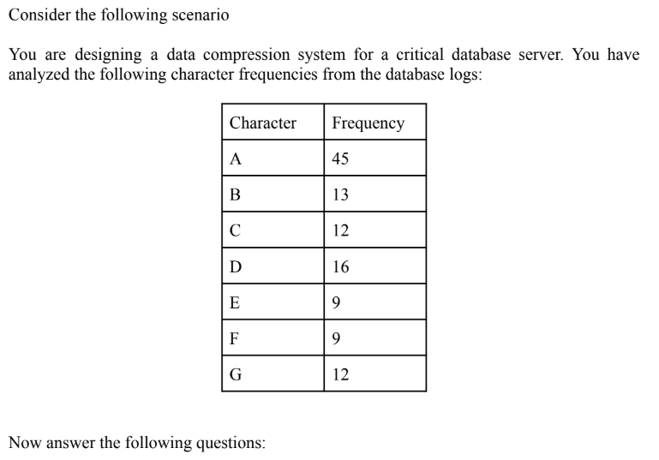

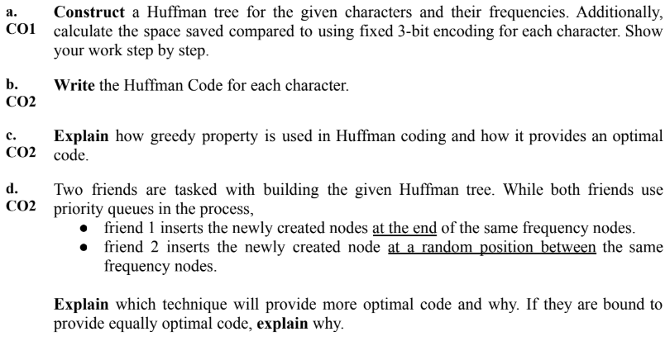

1. You are given two strings, '**cbabdcb**' and '**badcbc**'. You want to send these strings as an encoded message. After merging them into one string, '**cbabdcbbadcbc**', now you need an efficient text-encoding algorithm with minimal space requirement.

i. Simulate the encoding process,

ii. construct any needed tables or trees,

iii. generate the codeword for each character,

iv. show the encoded message and

v. the total number of bits required to store it.